**Gem5 Installation**

First I tried to get Gem5 works on Windows 10 using docker , it works but it was difficult to debug and it took more time because I’m not used to work with Docker that much.

The second platform I used the usual method, which using a fresh installed Linux distro for Gem5.

I installed Linux Mint 22.1 on my laptop as main OS , and I followed these steps to get Gem5 works.

**1- Make sure the system is updated using these commands :**

sudo apt update

sudo apt upgrade -y

**2- Install Required Dependencies : Gem5 needs some software packages to build and work (Dependencies) . Install them using :**

sudo apt install -y build-essential git m4 scons zlib1g zlib1g-dev libprotobuf-dev protobuf-compiler libprotoc-dev libgoogle-perftools-dev python3-dev python3-pip python-is-python3 git

**3- Download Gem5 : get Gem5 source code using Git:**

git clone <https://github.com/gem5/gem5.git>

Now we have gem5 directory and we can access using **cd gem5** .

There are two remained requirements to install “mypy and pre-commit” which are python library , we can install them using the command :

pip install -r requirements.txt

or by simply using apt :

sudo apt install python3-mypy pre-commit

**- Building Gem5 using scons :**

Gem5 directory includes all valid ISAs (Instruction Set Architectures) as followed :

**ARM**

**NULL**

**MIPS**

**POWER**

**RISCV**

**SPARC**

**X86**

Some of these ISAs have more than one type we can build , and we can use ALL to compiles Gem5 for all supported CPU architectures (X86, ARM, RISC-V, etc.). .

First : we use **nproc** command to display the number of available processing units. In my laptop I have 12 as shown.

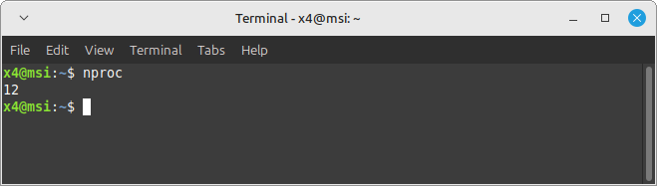

I have to use more than one core in building process to make it faster .

In gem5 directory I executed this command

scons build/[ISA]/gem5.opt –j [Number of cores]

I tried to build ALL using 9 cores by this command :

**scons build/ALL/gem5.opt –j 9**

It took about 2 hours to complete , and after using Gem5 I build another platform for Intel/AMD only by using   
**scons build/X86/gem5.opt –j 9**

It took about 30 minutes to complete.

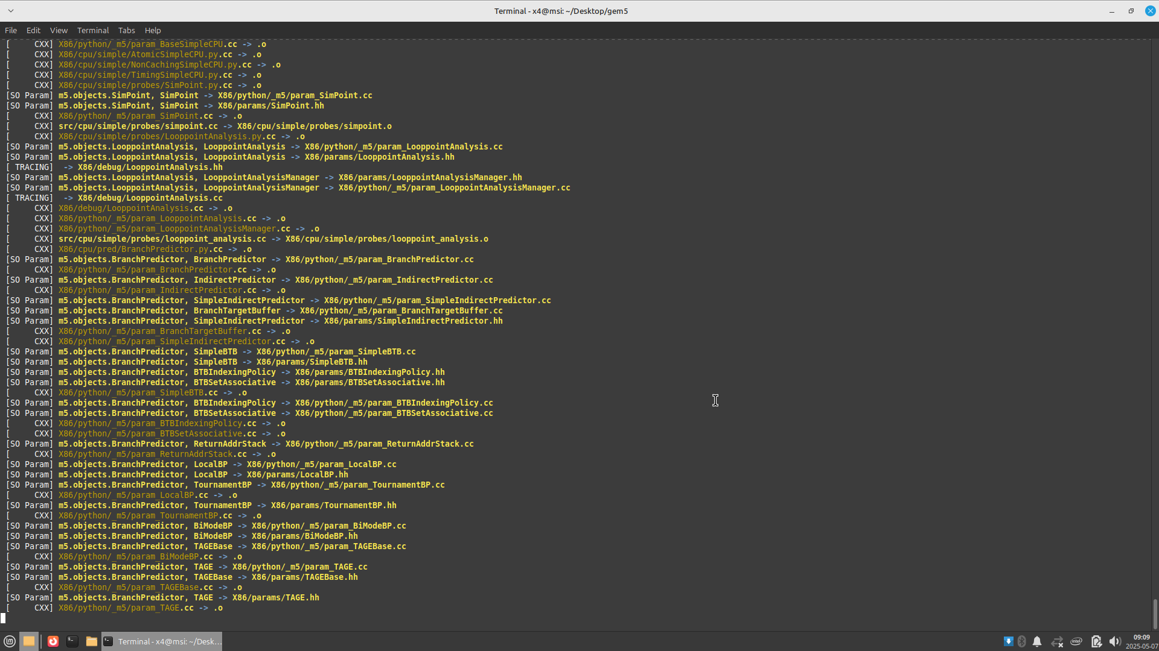

We can see the compiled ISAs inside build sub-directory in Gem5.

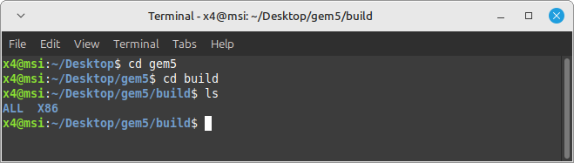

By these steps we have Gem5 ready to use on our system.